# Please find the application screenshots below:

## Login:

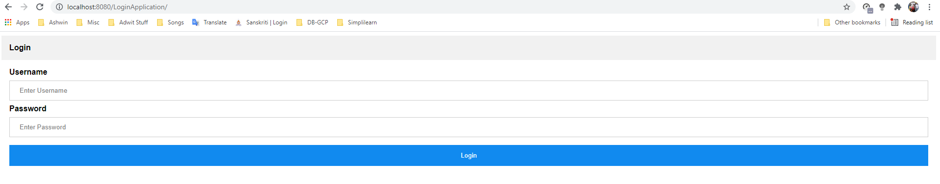

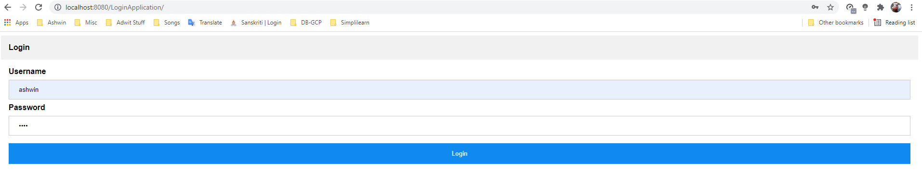

## Dashboard:

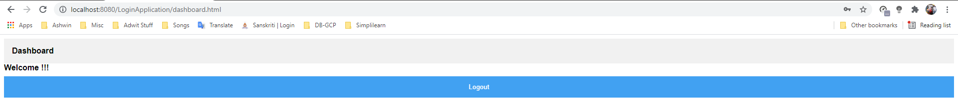

## Logout:

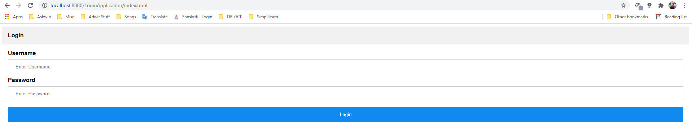

## Invalid User:

